Q1. Write a java program to read the characters from a file, if a character is alphabet then reverse its case, if not then display its category on the Screen. (whether it is Digit or Space)
[Marks 30]
Q2. Write HTML and CSS code to design a web page. Divide the browser screen into two frames. The first frame will display the heading. Divide the second frame into two columns. The frame on the right contains a image of “Home and Kitchen Appliances”. The frame on the left contains a menu consisting of hyperlinks. Clicking on any one of these hyperlinks will display related information in a new page as shown below.
Use External style sheet with appropriate attributes to display information of each frame.

Home Shopping |  |  | Kitchen & Dining  - Cookware  - Kitchenware  - Bakeware  - Serveware
Image of  Home and Kitchen Appliances | Home & Kitchen appliances  - Kitchen & Dining  - Furnishings  - Home Décor  - Home Improvement
[Marks 30]
Q3. Write a Vb.net program to check whether entered string is palindrome or not. [Marks 20]
Q4. Journal [Marks 10]
Q5. Viva [Marks 10]

Q1. Write a java program to accept n names of cites from user and display them in descending order. [Marks 30]
Q2. Write HTML and CSS code to design a web page displaying list of hyperlinks. Divide the browser screen into two frames. The first frame will display the heading. Divide the second frame into two columns. The frame on the left will be a menu consisting of hyperlinks. Clicking on any one of these hyperlinks will display related information as a new page which must be open in frame on the right hand side.
Use Inline style sheet with appropriate attributes to display information of each frame.

IT Industries in INDIA
City  - Pune  - Banglore  - Hydrabad  - Delhi | Pune  - Infosys  - TCS  - Tech-Mahindra  - Persistent
[Marks 30]
Q3. Write a Vb.net program for blinking an image. [Marks 20]
Q4. Journal [Marks 10]
Q5. Viva [Marks 10]

Q1. Write a java program to accept the details of ‘n’ employees (EName ,Salary) from the user, store them into the Hashtable and displays the Employee Names having maximum Salary.
[Marks 30]
Q2. Write a JavaScript to create an image slider.(Use array to store images) [Marks 30]
Q3. Write a Vb.Net program to move the Text “Dr D Y Patil College” continuously from Left to Right. [Marks 20]
Q4. Journal [Marks 10]
Q5. Viva [Marks 10]

Q1. Design a screen in Java to handle the Mouse Events such as MOUSE_MOVED and MOUSE_CLICK and display the position of the Mouse_Click in a TextField. [Marks 30]
Q2.Write a JavaScript Program to read a number from user, store its factors into the array and display that array. (Handle onClick Event)
[Marks 30]

Q3. Write a Vb.net program to accept a number from an user through InputBox and display its multiplication table into the ListBox. [Marks 20]
Q4. Journal [Marks 10]
Q5. Viva [Marks 10]

Q1. Define a class Student with attributes rollno and name. Define default and parameterized constructor. Override the toString() method. Keep the count of Objects created. Create objects using parameterized constructor and Display the object count after each object is created. [Marks 30]
Q2. Write HTML and CSS code to design a web page. Divide the browser screen into two frames. The first frame will display the heading. The second frame contains a menu consisting of hyperlinks. Clicking on any one of these hyperlinks will display related information in a new page as shown below.
Use Internal style sheet with appropriate attributes to display information of each frame.
COMPUTER SCIENCE DEPARTMENT |  | F.Y. B.C.A. Exam Time Table
  Date | Time | Subject Code | Subject Name
  12/10/2015 | 10:30 am – 1:30pm | 101 | PPA
  13/10/2015 | 10:30 am – 1:30pm | 102 | MOE
  14/10/2015 | 10:30 am – 1:30pm | 103 | BC
  15/10/2015 | 10:30 am – 1:30pm | 104 | PM
  16/10/2015 | 10:30 am – 1:30pm | 105 | FA
[Marks 30]
Q3. Write a Vb.net program to accept n numbers through InputBox and count the number of Armstrong and Perfect numbers among them and display their count by using messagebox. [Marks 20]
Q4. Journal [Marks 10]
Q5. Viva [Marks 10]
Q1. Create a calculator with functionality in an Applet.
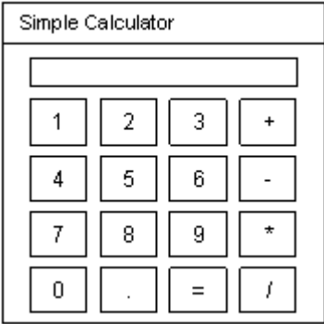 [Marks 30]
Q2. Write a JavaScript program to read a character string from user and perform the following functions:
  - Accept a character from user and count the number of occurrences of that character in the string.
  - Accept a Position from user and print the character at specified position.

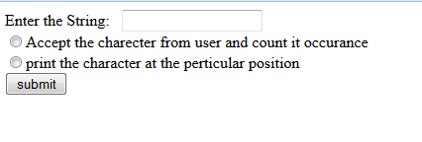 [Marks 30]

Q3. Write a Vb.net program to add two TextBoxes, two Labels and one button at runtime. Accept two numbers in textboxes and handle DivideByZeroException.
[Marks 20]
Q4. Journal [Marks 10]
Q5. Viva [Marks 10]

Q1. Write a java program to display “Hello Java” with settings Font- Georgia, Foreground color- Red, background color – Blue on the Frame.
[Marks 30]
Q2. Write HTML code to design a website for Online Shopping. Design two pages which contains hyperlink to each other. All pages must have different background.
Divide the first home page horizontally into two frames. The first frame contains logo and name of the shopping site. Divide the second frame vertically in two frames out of which First(right) frame displays two hyperlink images such as Mobiles, Car and second(left) frame displays information about shopping site in scrolling form.
Divide the second page vertically in two frames. The first frame displays Category list (which are again hyperlinked) Clicking on any one of these hyperlinks will display related information (Image, Name of the Model & Price) of the category in a second frame. [Marks 30]

Q3. Write a Vb.net program to design following screen, accept the details from the user. Clicking on Submit button Net Salary should be calculated and displayed into the TextBox. Display the MessageBox informing the Name and Net Salary of employee.
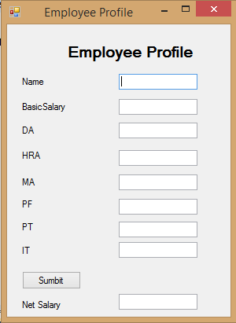 [Marks 20]
Q4. Journal [Marks 10]
Q5. Viva [Marks 10]

Q1. Write a java program to design a following GUI (Use Swing). [Marks 30]
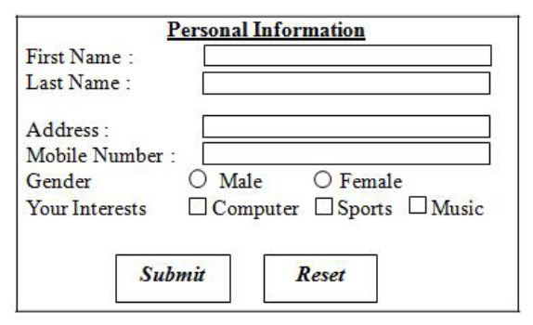
Q2. Write a JavaScript program to design student registration form and perform following validation:
- Check all fields should not contain a null value
- Check name field contains only alphabets
- Mobile No. field should be of 10 digits.s
- Pin code field should be of 06 digits.
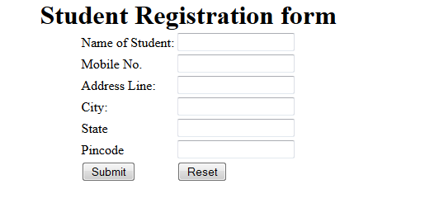 [Marks 30]

Q3. Write a Vb.net program to accept number from user into the TextBox. Calculate the square root of that number also convert the entered number into binary number and display result into the Message Box [Marks 20]
Q4. Journal [Marks 10]
Q5. Viva [Marks 10]

Q1. Write a java program to display the contents of a file in reverse order. [Marks 30]
Q2. Write HTML code to design a website of facebook. Design three pages Home, Profile and Find Friends Request page which are linked to each other. Design First two pages of website (Home &Profile ) as shown below. And Third page (Find Friends Request) contains information as Image ,Name of Sender ,And two buttons Confirm and Delete.
Welcome to Ivan Bayross
Logout
Home
Profile
Find Friends
Raj shared this link
Image
Like
Share
Comment
Profile Page
Home
Ivan Bayross
Comment / Message
Timeline
About
Friends
Photo
Post

[Marks 30]
Q3. Design a Vb.net form to pick a date from DateTimePicker Control and display day, month and year in separate text boxes. [Marks 20]
Q4. Journal [Marks 10]
Q5. Viva [Marks 10]

Q1. Write an applet application in Java for designing Temple. [Marks 30]

Q2. Write HTML code to design a website for Flight Reservation.
AirIndia
Logo
India
Home
Manage Your Trip
Booking Information
From :
To :
Departure Date :
Returning Date :
Adults
Children
1 to 9
0 to 9
Economy
Executive
First
Book Now
Manage Your Trip

Fare Details for Air India

Home

Class

Economy

Executive

First
Fare

10,000 /-

20,000/-

30,000/-

[Marks 30]

[Marks 30]
Q3. Write a Vb.net program to accept a character from keyboard and check whether it is vowel or not. Also display the case of that character. [Marks 20]
Q4. Journal [Marks 10]
Q5.Viva [Marks 10]

Q1. Write a java program to accept Employee name from the user and check whether it is valid or not. If it is not valid then throw user defined Exception “Name is Invalid” otherwise display it. [Marks 30]
Q2. Write a Java Script program to design Customer Account Details Form and perform validation on pan number field. (pan number is of only 10 characters long, out of which first 5 characters are alphabets, next 4 characters are digits and last character is alphabet )
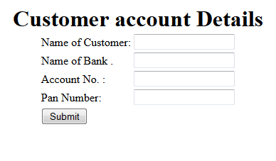 [Marks 30]
Q3. Write a Vb.net program to accept sentences in text box and count the number of words and display the count in message box. [Marks 20]
Q4. Journal [Marks 10]
Q5. Viva [Marks 10]

Q1. Write a java program to accept list of file names through command line and delete the files having extension “.txt”. Display the details of remaining files such as FileName and size. [Marks 30]
Q2. Write a JavaScript program to compare the values of password and confirmed password field and display message accordingly. Also perform the validation to check any of the field should not be empty.
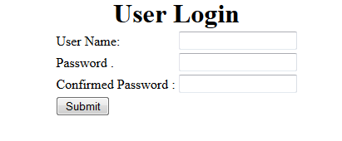 [Marks 30]
Q3. Write a Vb.net program to design the following form, accept the numbers through textbox and add them into the ListBoxe1 by clicking on Add button. When user click on Prime button then all the prime numbers from ListBox1 should get added into ListBox2.
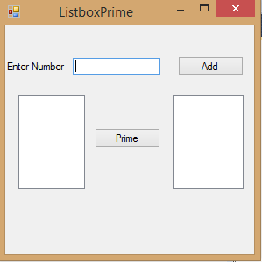 [Marks 20]
Q4. Journal [Marks 10]
Q5. Viva [Marks 10]

Q1. Write a java program to copy the contents of one file into the another file, while copying change the case of alphabets and replace all the digits by ‘*’ in target file. [Marks 30]
Q2. Write a JavaScript Program to accept user name and password from a user if user is valid then display his score card on the next page as shown below.
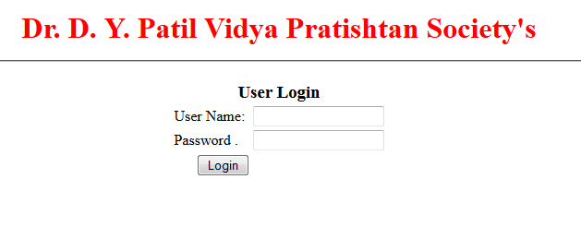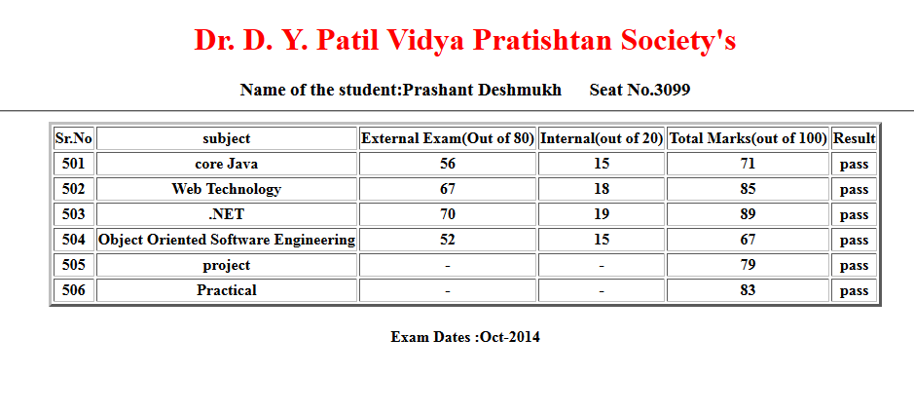 [Marks 30]
Q3. Write a Vb.net program to design the following form, allow the user to select radio buttons from Gender and Age Panel. After Selection appropriate CheckBox from Right Panel should be selected automatically. Display appropriate message into the MessageBox by clicking on Ok button.
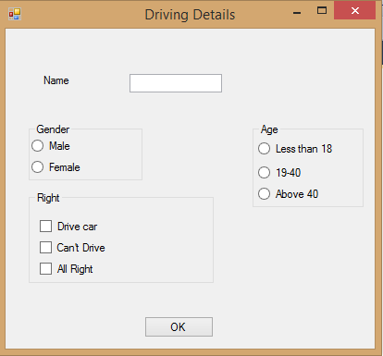
[Marks 20]
Q4. Journal [Marks 10]
Q5. Viva [Marks 10]

Q1. Write a Java program which will create a frame if we try to close it, it should change it’s color and it remains visible on the screen(Use swing). [Marks 30]
Q2. Write a JavaScript program to read employee details and generate pay slip which will calculate netsalary of an employee.
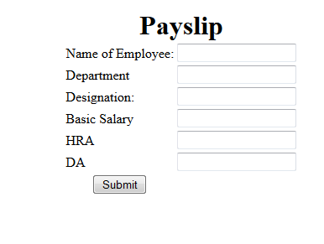 [Marks 30]
Q3. Write a Vb.net program to design the following form, select the question number from combo box that question will be displayed into textbox and the options for that question will be displayed on four radio buttons, select option and click on submit button result should be displayed in another textbox.
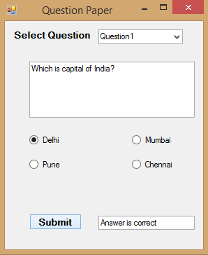 [Marks 20]
Q4. Journal [Marks 10]
Q5. Viva [Marks 10]

Q1. Define an abstract class Shape with abstract methods area() and volume(). Write a java program to calculate area and volume of Cone and Cylinder. [Marks 30]
Q2. Write a PHP script to accept the details of Employee(EName, Designation, Department Gender ,Salary) and display it on next page.

Male Female

EName

Designation

Department

Gender

Salary

Submit
Reset

[Marks 30]
Q3. Write a Vb.net program to generate Sample TreeView control shown in following form:
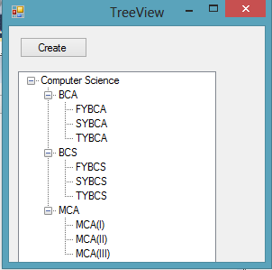 [Marks 20]
Q4. Journal [Marks 10]
Q5. Viva [Marks 10]

Q1.Write an application in Java using Awt to display 4 X 4 squares on the screen. One of the block will be active with black color. All other blocks should be filled with blue color. Provide command buttons as follows to move the active cell. The active cell should be changed only if it is within the boundary of the squares otherwise give the beep.
←
↓
↑
→
[Marks 30]
Q2. Write a PHP script to set selected image from ComboBox (DropDownList) to the background of Page. [Marks 30]
Q3. Write a Vb.net program to design the following form, it contains the three menus Color (Red,Blue,Green) ,Window(Maximize, Minimize, Restore) and Exit. On Selection of any menu or submenu result should affect the form control( for example if user selected Red color from Color menu back color of form should get changed to Red and if user selected Maximize from Window Menu then form should get maximized).
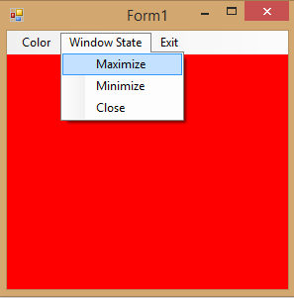
[Marks 20]
Q4. Journal [Marks 10]
Q5.Viva [Marks 10]
Q1. Write a Java program to design a screen using Awt that will take a user name and password. If the user name and password are not same, raise an Exception with appropriate message. User can have 3 login chances only. Use clear button to clear the TextFields. [Marks 30]
Q2.Write a PHP script to display a Multiplication table in tabular format. Design HTML page to accept a value. [Marks 30]
Q3. Write a Vb.net program to design the following form, this program shows the details of students in the form of form (use split container or Groupbox control to separate the input and output session). [Marks 20]
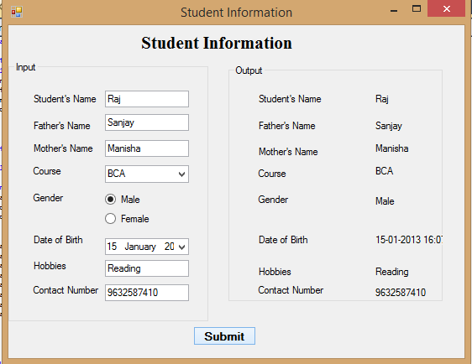
Q4. Journal [Marks 10]
Q5. Viva [Marks 10]

Q1. Write a java program that displays the number of characters, lines & words from a file. [Marks 30]
Q2. Write a PHP script to change Background color of the browser using switch statement according to day of the week. [Marks 30]
Q3. Write a Vb.net program to design the following form, accept all details from user and display the details through message box.
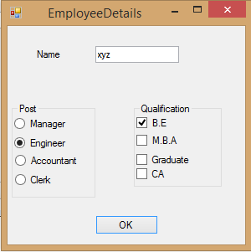 [Marks 20]
Q4. Journal [Marks 10]
Q5. Viva [Marks 10]

Q1. Write a java program to accept a number from the user, if number is zero then throw user defined Exception “Number is 0” otherwise calculate the sum of first and last digit of a given number (Use static keyword). [Marks 30]
Q2. Design a HTML page to accept a number and write a PHP script to display that number in words
e.g. 123 -→ one two three
[Marks 30]
Q3. Develop the menu based Vb.net application to implement a text editor with cut, copy, paste, save, close operations.
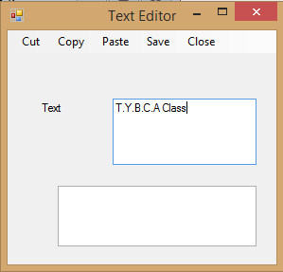
[Marks 20]
Q4. Journal [Marks 10]
Q5. Viva [Marks 10]

Q1. Write a package for Games in Java, which have two classes Indoor and Outdoor. Use a function display () to generate the list of players for the specific games. (Use Parameterized constructor, finalize() method and Array Of Objects) [Marks 30]
Q2. Design a HTML form to accept a String. Write a PHP function to count the total number of vowels (a,e,i,o,u) from the string. Show the occurrences of each vowel from the string
[Marks 30]
Q3. . Write a VB.NET program to do the following operations on RichTextBox values
i) Font Style
ii) Font Color
iii) Save
iv) Open
[Marks 20]
Q4. Journal [Marks 10]
Q5. Viva [Marks 10]

Q1. Write a Java program to design a screen using Swing that will create four TextFields. First for the text, second for what to find and third for replace. Display result in the fourth TextField. Display the count of total no. of replacements made. The button clear to clear the TextFields.
Enter Text
Text To Find
Text to Replace
No. Of occurrences
Find
Find and Replace
Replace
Clear

[Marks 30]
Q2. Design a HTML form to accept two numbers from the user. Give options to choose the arithmetic operation (use radio buttons). Write a PHP function to display the result on the next form. (Use the concept of function and default parameters)
[Marks 30]
Q3. Write a VB.NET program to create a table Patient (Pid, PName, Contact_No, Disease). Insert records into table and display appropriate message in message box. (Use MS Access to create db)
[Marks 20]
Q4. Journal [Marks 10]
Q5. Viva [Marks 10]

Q1. Define an Interface Shape with abstract method area(). Write a java program to calculate an area of Circle and Sphere.(use final keyword) [Marks 30]
Q2. Design a HTML form to accept two strings from the user. Write a PHP function to find the first occurrence and the last occurrence of the small string in the large string. Also count the total number of occurrences of small string in the large string. Provide a text box to accept a string, which will replace the small string in the large string. (Use built-in functions)
[Marks 30]

Q3. Write a VB.NET program to create a table Employee (Eid, EName, Designation, doj). Insert records into table and display it in GridView. (Use SQLServer to create db) [Marks 20]
Q4. Journal [Marks 10]
Q5. Viva [Marks 10]

Q1. Write a java program to accept the details of n Cricket Players from user (Player code, name, runs, innings- played and number of times not out). The program should contain following menus:
-Display average runs of a single player.
-Display average runs of all players. (Use array of objects, Method overloading and static
keyword) [Marks 30]
Q2. Design HTML page to read the value for n. Write a PHP script to display first n even numbers with font size = 12 and color = red and first n odd numbers with font face = Times new Roman , size = 17 & color = yellow.
[Marks 30]
Q3. Write a VB.NET program to create a table student (RollNo ,SName, Class). Insert the records (Max: 5). Update class of students to ‘TYBCA’ whose class is ‘SYBCA’ and display updated records in GridView. (Use MS Access to create db) [Marks 20]
Q4. Journal [Marks 10]
Q5. Viva [Marks 10]

Q1. Write a Java Program to accept the details of Employee(Eno, EName,Sal) from the user and display it on the next Frame. (Use AWT)
[Marks 30]

Q2. Design a HTML form to accept two strings from the user. Write a PHP function to find whether the small string appears at the start of the large string. Provide a text box to accept the string that will replace all occurrences of small string present in the large string. Also split the large string into separate words. (Use regular expressions) [Marks 30]

Q3. Write a VB.NET program to create teacher table (Tid , TName, subject). Insert the records (Max : 5). Search record of a teacher who teaches “VB.NET” subject and display result in GridView. (Use SQL to create db) [Marks 20]
Q4. Journal [Marks 10]
Q5. Viva [Marks 10]

Q1. Define an Employee class with suitable attributes having getSalary() method, which returns salary withdrawn by a particular employee. Write a class Manager which extends a class Employee, override the getSalary() method, which will return salary of manager by adding traveling allowance, house rent allowance etc.
[Marks 30]
Q2. Design a HTML form to accept email address from the user. Write a PHP function using regular expressions check for the validity of entered email-id. The @ symbol should not appear more than once. The dot (.) can appear at the most once before @ and at the most twice or at least once after @ symbol. The substring before @ should not begin with a digit or underscore or dot or @ or any other special character. (Use explode and ereg function.)
[Marks 30]
Q3. . Write a VB.NET program to create movie table (Mv_Name, Release_year, Director). Insert the records(Max: 5). Delete the records of movies whose release year is 2015 and display appropriate message in messagebox.(Use MS Access to create db)
[Marks 20]
Q4. Journal [Marks 10]
Q5. Viva [Marks 10]

Q1.Write a java Program to accept ‘n’ no’s through the command line and store all the prime no’s and perfect no’s into the different arrays and display both the arrays.
[Marks 30]
Q2. Write a menu driven program in PHP to perform the following operations on an associative array:
i. Display the elements of an array along with the keys.
ii. Display the size of an array
iii. Delete an element from an array from the given index.
iv. Reverse the order of each element’s key-value pair [Hint: use array_flip()]
v. Traverse the elements in an array in random order [[Hint: use shuffle()].

[Marks 30]
Q3. Write a VB.NET program to accept the details of customer (CName, Contact_No, Email_id). Store it into the database with proper validation and display appropriate message by using Messagebox.(Use MS Access )
[Marks 20]
Q4. Journal [Marks 10]
Q5. Viva [Marks 10]

Q1.Write a java program to accept the details employee (Eno, Ename ,Salary) and add it into the JTable by clicking on the Button.(Max : 5 Records) [Marks 30]
Q2. Write a PHP Script for the following:
- Declare a Multidimensional Array.
- Display specific element from a Multidimensional array.
- Also delete given element from the Multidimensional array.
- Define an array.
- Find the element from the array that matches the given value using appropriate search function.
[Marks 30]
Q3. Write a VB.NET program to accept the details of product (pid, pname, expiry_date, price). Store it into the database and display it on the Crystal Report.(Use SQL Server) [Marks 20]
Q4. Journal [Marks 10]
Q5. Viva [Marks 10]

Q1. Write a java program to read n Students names from user, store them into the ArrayList collection. The program should not allow duplicate names. Display the names in Ascending order. [Marks 30]
Q2. Write a menu driven program in PHP to perform the following stack and queue related operations:[Hint: use Array_push(), Array_pop(), Array_shift(), array_unshift() functions]

i. Insert an element in stack
ii. Delete an element from stack
iii. Display the contents of stack
iv. Insert an element in queue
v. Delete an element from queue
vi. Display the contents of queue
[Marks 30]
Q3. Write a VB.NET program to accept the details Supplier (SupId, SupName, Phone_No, Address ) store it into the database and display it. (Use Crystal Report) [Marks 20]
Q4. Journal [Marks 10]
Q5. Viva [Marks 10]

Q1. Write a java program to accept n employee names from user, store them into the LinkedList class and display them by using.
- Iterator Interface
- ListIterator Interface
[Marks 30]
Q2.Write a menu driven program in PHP to perform the following operations on associative arrays:
1. Sort the array by values (changing the keys) in ascending, descending order.
2. Also sort the array by values without changing the keys.
3. Filter the odd elements from an array.
4. Sort the different arrays at a glance using single function.
5. Merge the given arrays.
6. Find the intersection of two arrays.
7. Find the union of two arrays.
8. Find set difference of two arrays.
[Marks 30]
Q3. Write a VB.NET program to create Author table (aid , aname , book_name). Insert the records (Max 5). Delete a record of author who has written “VB.NET book” and display remaining records on the Crystal Report.(Use MS Access to create db)
[Marks 20]
Q4. Journal [Marks 10]
Q5. Viva [Marks 10]

Q1. Write an applet application in Java for smile face.

[Marks 30]
Q2. Write a JavaScript program to Display current Day, Date, Month, Year and Time on the web page and greet the user accordingly. [Marks 30]
Q3. Write a VB.NET program to create player table (Pid,PName,Game, no_of_matches). Insert records and update number of matches of ‘Sachin Tendulkar’ and display result in Crystal Report.(Use SQL to create db)
[Marks 20]
Q4. Journal [Marks 10]
Q5. Viva [Marks 10]

